**AI and openAI -Achievement URL Redemption Steps**

1. Open an Incognito window, in a new tab, paste the following Achievement URL and click enter.  
     
   [https://learn.microsoft.com/en-us/users/me/achievements?redeem=D427L4&WT.mc_id=ilt_partner_webpage_wwl&ocid=6236893](https://ind01.safelinks.protection.outlook.com/?url=https%3A%2F%2Flearn.microsoft.com%2Fen-us%2Fusers%2Fme%2Fachievements%3Fredeem%3DD427L4%26WT.mc_id%3Dilt_partner_webpage_wwl%26ocid%3D6236893&data=05%7C02%7CKiran%40meteoros.in%7Cf8cc9bcbb34b4a9017b308dc97466c6d%7Ce286c868a1dd469eb6862078f4936d8d%7C0%7C0%7C638551575918529573%7CUnknown%7CTWFpbGZsb3d8eyJWIjoiMC4wLjAwMDAiLCJQIjoiV2luMzIiLCJBTiI6Ik1haWwiLCJXVCI6Mn0%3D%7C0%7C%7C%7C&sdata=KVEFV9QMX55wKegSHDzAwVUqNniU1f6CT5DpIrSTH1M%3D&reserved=0)

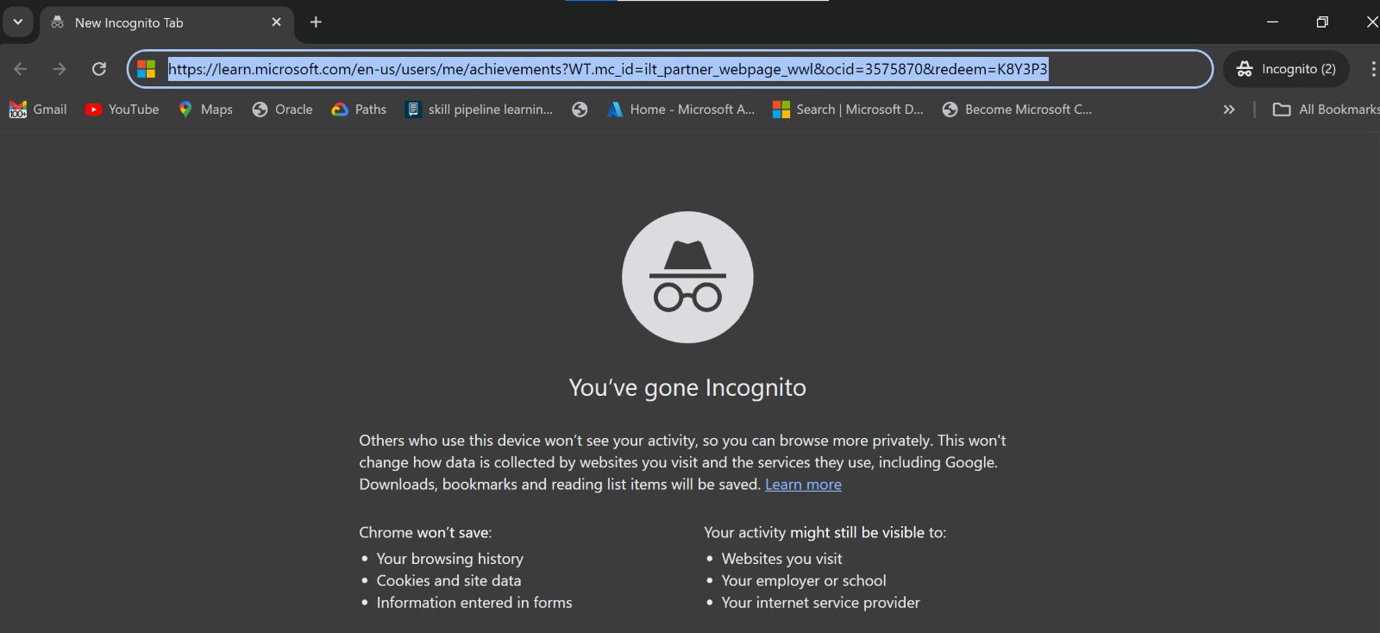

1. You will be asked to Sign in. Please Sign in using your **Personal Microsoft Account. (NOT EY Account)**

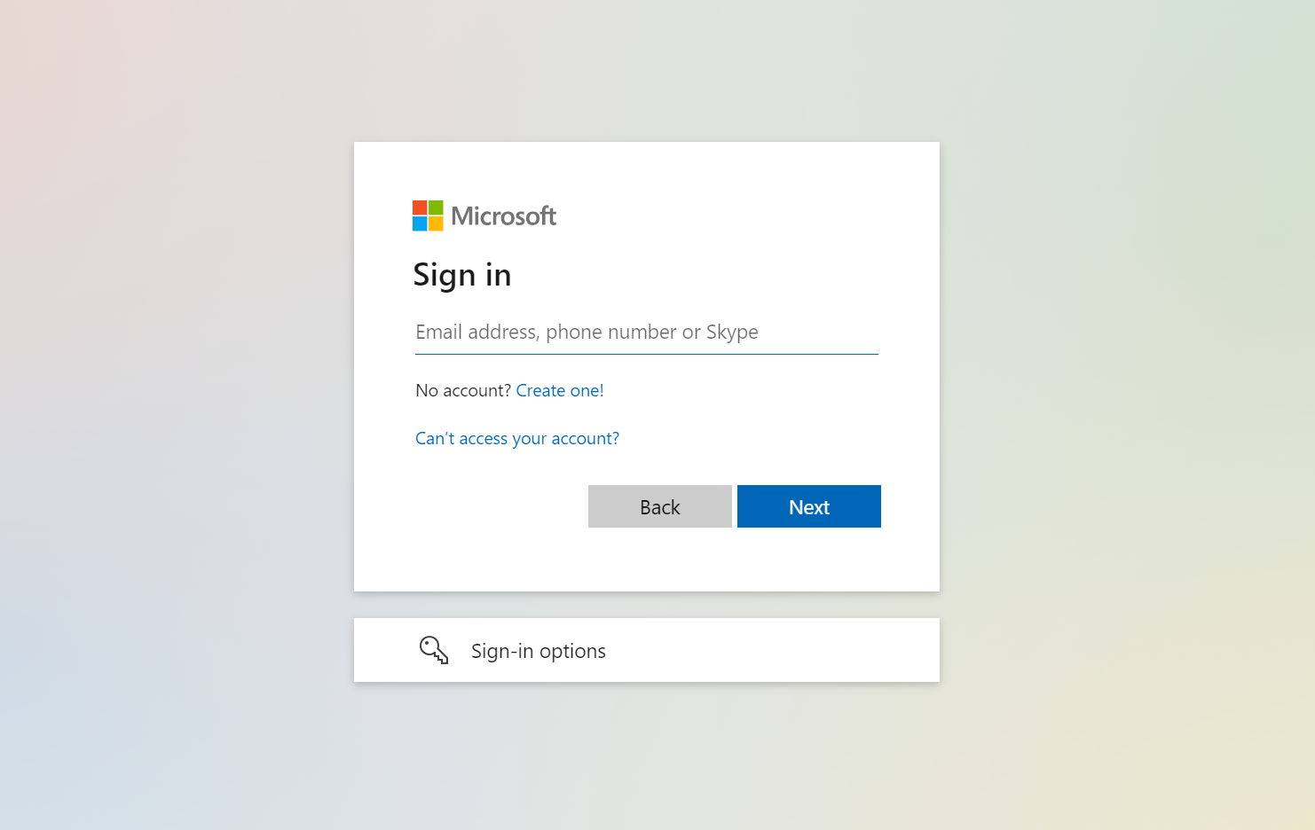

1. After successfully signing in, click on Redeem.

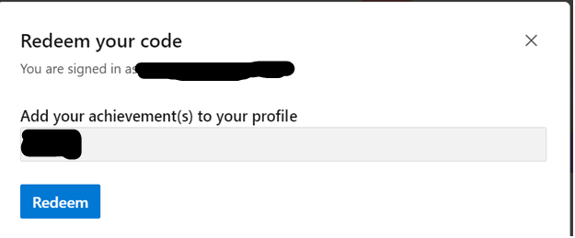

1. Upon successful redemption, you will be able to see the Badges, Modules and Trophies earned.

